Adjective Complement

✅ What Is an Adjective Complement?
# Source: AI Source: Provided by: [Data Path: Persons Table -> ID Column: 1, Name_En Column: Motasem Essam] -> From: [ChatGPT] on [8/4/2025]
An Adjective Complement is a word or phrase—often a prepositional phrase or clause—that completes the meaning of an adjective.
It follows the adjective and provides necessary information, such as reason, source, or target.

🔸 Key Features:
# Source: AI Source: Provided by: [Data Path: Persons Table -> ID Column: 1, Name_En Column: Motasem Essam] -> From: [ChatGPT] on [8/4/2025]
- Completes the sense of an adjective
- Usually comes immediately after the adjective
- Often takes the form of:
  - A prepositional phrase
  - A to-infinitive phrase
  - A noun clause (like a “that”-clause)
- Answers questions like:
  - Afraid of what?
  - Happy about what?
  - Eager to do what?

🔸 Common Adjectives That Take Complements:
# Source: AI Source: Provided by: [Data Path: Persons Table -> ID Column: 1, Name_En Column: Motasem Essam] -> From: [ChatGPT] on [8/4/2025]
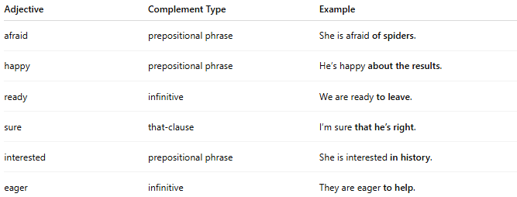
Adjective | Complement Type | Example
afraid | prepositional phrase | She is afraid of spiders.
happy | prepositional phrase | He’s happy about the results.
ready | infinitive | We are ready to leave.
sure | that-clause | I’m sure that he’s right.
interested | prepositional phrase | She is interested in history.
eager | infinitive | They are eager to help.

🔸 Examples in Sentences:
# Source: AI Source: Provided by: [Data Path: Persons Table -> ID Column: 1, Name_En Column: Motasem Essam] -> From: [ChatGPT] on [8/4/2025]
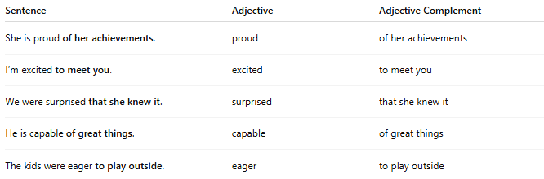
Sentence | Adjective | Adjective Complement
She is proud of her achievements. | proud | of her achievements
I’m excited to meet you. | excited | to meet you
We were surprised that she knew it. | surprised | that she knew it
He is capable of great things. | capable | of great things
The kids were eager to play outside. | eager | to play outside

🔸 How to Identify an Adjective Complement:
# Source: AI Source: Provided by: [Data Path: Persons Table -> ID Column: 1, Name_En Column: Motasem Essam] -> From: [ChatGPT] on [8/4/2025]
- Find an adjective in the sentence.
- Ask whether the phrase after it is essential to its meaning.
- If the sentence feels incomplete without it, it's an adjective complement.

